MilCamo-ReliDet

Reliability-Calibrated Selective Detection of Military Camouflaged Objects under Visibility Degradation
INCLUDE THE RESULTING IMAGES, DATASET IMAGES
Item | Corrected decision
Final project title | MilCamo-ReliDet: Reliability-Calibrated Selective Detection of Military Camouflaged Objects under Visibility Degradation
Primary dataset | MHCD2022
Task | Military camouflaged object detection using bounding boxes
Main scientific contribution | Reproducible corruption-robustness and confidence-reliability evaluation, plus a calibration/selective-detection adaptation on a strong detector
Later second-stage extension | MHCD-Seg segmentation only after licence, provenance and mask-quality clearance

2. Verified Dataset and Paper Gate
Resource | What is supported by the accessible source | Link status checked on 2 June 2026 | How we may use it
MHCD2022 repository | Author-linked public GitHub repository; README lists a Baidu download and extraction code k40o | Repository page opens and contains the listed download reference | Primary dataset source; archive must still be downloaded and audited
MHNet paper | Neurocomputing 2023 paper introducing MHNet and MHCD2022; search/publisher record is available | Paper landing/search result verified | Cite as original dataset/method paper
MHCD-Seg repository | Repository states it is a pixel-level extension of MHCD2022 with 3,000 images, five classes, 2,400/600 split and expert-refined SAMMCOS masks | Repository page opens and provides a Google Drive link | Audit only initially; primary segmentation use is permission-gated
3DSMCOS paper | Associated MAPR 2025 paper is cited by the MHCD-Seg repository | Association verified through repository record | Required related work before any segmentation extension
MCAM paper | Peer-reviewed article reports a military COD dataset and combines military/non-military data | Publisher/search record verified | Related work only until public dataset access/licence is verified
TEA-DETR preprint | Texture-edge augmented framework for military camouflaged people detection; directly overlaps the old proposed method | Research Square record/PDF verified | Mandatory related work; do not duplicate its central method
Awesome-COD repository | Active curated COD literature list, updated through 1 June 2026 | Correct repository page verified | Literature tracking resource only

3. Source Links
Type | Resource | Link | Student action
Primary dataset repository | MHCD2022 GitHub | Open repository | Read README and download data
Download cited by repository | MHCD2022 Baidu archive | Open download page | Use extraction code k40o; report if inaccessible
Original paper | Extraordinary MHNet | Open DOI record | Read before dataset audit
Optional segmentation repository | MHCD-Seg / 3DSMCOS | Open repository | Audit only after primary detection pipeline
Optional segmentation archive | MHCD-Seg Google Drive link listed in repository | Open archive link | Do not use in main results before clearance
Optional segmentation paper | 3DSMCOS | Open DOI record | Read before optional segmentation
Related military dataset paper | MCAM article | Open DOI record | Related work; dataset use not currently approved
Overlap warning paper | TEA-DETR preprint | Open Research Square DOI | Must be cited; do not copy its central idea
COD literature tracker | Awesome-COD repository | Open repository | Check monthly for new overlapping papers
Additional curated COD tracker | visionxiang/awesome-camouflaged-object-detection | Open repository | Secondary literature tracker

4. Research Gap

Already covered in the literature:

· MHNet introduced MHCD2022 and a military camouflage detection network.

· MilDetr already studies a military camouflage detection transformer.

· TEA-DETR already targets texture-edge augmented military camouflaged people detection.

· MHCD-Seg/3DSMCOS already proposes pixel-level military camouflage masks and synthetic segmentation data.

· General COD already includes SAM-based and uncertainty-aware approaches.

Appropriate:

Build a reproducible reliability and corruption-robustness evaluation protocol for real military camouflage detection on MHCD2022, and develop a confidence-calibrated selective-detection adaptation that reduces high-confidence errors and maintains detection quality under visibility degradation.

Proposed model name

MilCamo-ReliDet

Core method components
Component | Purpose
Strong base detector: RT-DETR or DINO after screening | Provide a modern detection backbone
Corruption-aware training views | Expose the model to illumination, haze, blur, compression and occlusion shifts during training
Detection-quality prediction head | Predict whether a detected box is likely to be reliable
Confidence calibration module | Reduce overconfident incorrect predictions
Selective detection policy | Allow predictions below a reliability threshold to be flagged for review rather than treated as trusted
Consistency regularisation | Encourage stable boxes/classes between clean and degraded training views

Why this is different from TEA-DETR
TEA-DETR central direction | This project central direction
Edge and texture feature enhancement for military camouflaged people detection | Reliability calibration and selective detection under visibility degradation
Detection accuracy via texture-edge architectural modules | Error awareness, calibration, robust AP and risk-coverage behaviour
Reported on CPDD/HCPD in the preprint | Main primary benchmark begins with MHCD2022 after audit

Project Title

MilCamo-ReliDet: Reliability-Calibrated Selective Detection of Military Camouflaged Objects under Visibility Degradation

Primary Goal

Develop a complete Army/military-specific camouflaged object detection research paper using real military camouflage images, robust detector baselines, difficult-condition testing, and a proposed reliability-aware detection model.

Main Task Type

Object Detection using bounding boxes

Main Dataset

MHCD2022: Military High-Level Camouflage Detection Dataset

Project Execution Plan
Stage | Work to Complete | Main Output
1 | Download and verify the primary dataset | Verified MHCD2022 dataset folder
2 | Organise dataset and convert labels | YOLO and COCO annotation formats
3 | Audit the dataset completely | Dataset statistics and visualisation report
4 | Run the first detector baseline | YOLO11 result table
5 | Expand detector baselines | Faster R-CNN, RT-DETR and DINO results
6 | Test difficult visibility conditions | Robustness benchmark table
7 | Analyse failures | Failure taxonomy and motivation figures
8 | Implement the proposed model | MilCamo-ReliDet
9 | Run ablation study | Module-wise evidence
10 | Measure reliability and efficiency | Calibration and runtime tables
11 | segmentation extension | Only after MHCD-Seg permission

TASK 1: Download the Required Dataset and Related Resources

1.1 Primary Dataset: Download First (Done)
Dataset | Link | Details | Use in Project | Status
MHCD2022 | GitHub repository: https://github.com/liumaozhen-lmz/Military-Camouflage-MHCD2022 | Military camouflage dataset associated with the MHNet paper. Reported size: 3,000 images, five categories, multiple real-world military camouflage scenes. | Main training and testing dataset | Required
MHCD2022 Direct Download | https://pan.baidu.com/s/1gBNqHb0RbQ1EGImi3l1AjQ | Extraction code: k40o | Download archive | Required
MHNet Paper | https://doi.org/10.1016/j.neucom.2023.126466 | Original dataset and military camouflage detector paper | Related work and dataset source | Required reading

1.2 Dataset: Use after first (if you have any other also list that)
Dataset | Link | Details | Use in Project | Status
MHCD-Seg | https://github.com/hangtruong85/MHCD-Seg | Claims a pixel-level mask extension of MHCD2022 with 3,000 images and five classes | Possible future segmentation extension | Permission and licence required
MHCD-Seg Download | https://drive.google.com/file/d/1NK8nxM626adBSGXAaUstaQpnGTIltQae | Repository-provided Google Drive archive | Audit only initially | Do not use in main results yet
3DSMCOS Paper | https://doi.org/10.1109/MAPR67746.2025.11133731 | Associated synthetic-data and military segmentation paper | Related work | Required reading before segmentation extension
ACD1K | https://www.kaggle.com/datasets/aalihhiader/military-camouflage-soldiers-dataset-mcs1k | Used in a Paper. It includes 1000 images of Camouflaged soldiers in diverse Conditions |  | Already Downloaded

1.3 Related Dataset: Reference Only Until Public Download Is Found (if get use that)
Dataset | Link | Details | Use
MCAM | https://doi.org/10.1177/15485129241233299 | Military camouflaged object dataset described in a peer-reviewed paper; official public download not verified | Related work only
MCOD-UAV | Search through the associated military UAV COD paper and authors | UAV military camouflage detection dataset; download not yet verified | Future cross-domain extension only

TASK 2: Verify Dataset Access, Annotation Type and Usage Permission

After downloading MHCD2022, First check:
Check | What to Verify | Output
Archive opens correctly | No missing or corrupted extraction files | archive_verification.txt
Image count | Confirm total images | image_count_report.csv
Annotation availability | Confirm labels exist for images | annotation_check.csv
Annotation type | Determine whether labels are bounding boxes, masks or both | annotation_type_report.txt
Category names | Read exact class names from original annotations | class_names.txt
Split availability | Verify official training and testing split | split_verification.csv
Image-label match | Every labelled image has matching annotation | missing_label_report.csv
Visual label quality | Draw labels on at least 100 random images | label_visual_check/

TASK 3: Prepare the MHCD2022 Dataset

5.1 Keep the Raw Dataset Unchanged

Place the extracted original archive here:

data/raw/MHCD2022/

Never edit, rename or delete the raw files.

5.2 Inspect the Original Folder Structure

· total folders;

· total image files;

· annotation file formats;

· file extensions;

· possible train/test folders;

· class names;

· whether label files contain boxes or masks;

· corrupted files;

· missing images or annotations.

Convert Original Labels to YOLO Format

YOLO detection label format for every object:

class_id x_center y_center width height

All box coordinates must be normalised between 0 and 1.

Convert Original Labels to COCO Format

Required COCO JSON files:

data/processed/mhcd2022/annotations_coco/train.json

data/processed/mhcd2022/annotations_coco/val.json

data/processed/mhcd2022/annotations_coco/test.json

Each annotation must contain:

image_id

category_id

bbox

area

iscrowd

annotation_id

Create Train, Validation and Test Splits

Split rule:

· stratify by class wherever possible;

· keep similar object-size distribution across train and validation;

· do not move any official test images into train or validation;

· use fixed seed 42.

Outputs:

data/splits/train.txt

data/splits/val.txt

data/splits/test.txt

data/splits/split_summary.csv

TASK 6: Create the Dataset Manifest

The manifest file must be:

data/manifests/mhcd2022_manifest.csv

Required columns:

image_id,file_path,split,width,height,num_objects,class_ids,box_coordinates,object_area_ratios,annotation_type,source_dataset,license_status,notes

TASK 7: Complete Dataset Audit Before Training

Audit Operations

Audit Item | Required Output
Total number of images | Confirm dataset size
Total train images | Confirm train split
Total validation images | Confirm validation split
Total test images | Confirm untouched test split
Total object instances | Count all annotated boxes
Class-wise image count | Number of images containing each class
Class-wise instance count | Total object boxes per class
Image resolutions | Width, height, minimum, maximum, mean
Box area distribution | Object-area percentage
Small/medium/large objects | Scale distribution
Images with multiple objects | Detection difficulty
Missing annotations | Error report
Corrupted files | Error report
Duplicate images | Exact hash report
Near duplicate images | Perceptual hash report
Train/test overlap | Leakage report
Random visual label check | At least 100 labelled samples

7.2 Object Size Categories

Calculate:

object_area_ratio = bounding_box_area / full_image_area

Create categories:
Size | Rule
Small object | Object area < 1% of image
Medium object | 1% ≤ object area < 10%
Large object | Object area ≥ 10%

7.3 Manual Difficulty Tags

For at least 300 images, manually create additional difficulty labels:
Difficulty Tag | Meaning
Foliage background | Object hidden in grass/trees/vegetation
Soil or sand background | Object hidden against earth-coloured terrain
Urban background | Object hidden against buildings/debris
Water background | Maritime camouflage scene
Heavy concealment | Object very difficult to identify visually
Partial occlusion | Part of object blocked
Low illumination | Scene visually dark
Low contrast | Object and background look very similar
Small distant object | Target occupies very small region

Save:

data/reports/manual_difficulty_annotations.csv

7.4 Dataset Audit Outputs

data/reports/dataset_summary.csv

data/reports/class_distribution.csv

data/reports/object_size_distribution.csv

data/reports/resolution_distribution.csv

data/reports/missing_annotation_report.csv

data/reports/corrupted_files.csv

data/reports/duplicate_report.csv

data/reports/train_test_leakage_report.csv

data/reports/manual_difficulty_annotations.csv

outputs/figures/sample_label_visualisation.png

outputs/figures/class_distribution.png

outputs/figures/object_size_histogram.png

outputs/figures/difficulty_example_grid.png

7.5 First Dataset Table to Produce ( IF you have other dataset please list that )
Dataset | Task | Images | Classes | Label Type | Train | Validation | Test | Real/Synthetic | Main Use
MHCD2022 | Military COD Detection | Verify after download | Verify after download | Bounding boxes expected | Verify | Created from training only | Verify | Real | Primary benchmark
MHCD-Seg | Military COD Segmentation | Claimed 3,000 | Claimed 5 | Masks claimed | Claimed 2,400 | Not specified | Claimed 600 | Real derivative | Optional only after permission
MCAM | Military COD Segmentation | Reported in paper | Verify | Reported masks | Verify | Verify | Verify | Real | Related work only

TASK 8: Create the YOLO Dataset Configuration

TASK 9: Run the First Baseline Model — YOLO11

First Baseline Result Table
Dataset | Input | Detector | AP@0.5:0.95 ↑ | AP@0.5 ↑ | Precision ↑ | Recall ↑ | F1 ↑ | AP-S ↑ | AP-M ↑ | AP-L ↑ | FPS ↑
MHCD2022 | Raw RGB | YOLO11-s (100 epochs) | 0.406923 | 0.639971 | 0.803039 | 0.581678 | 0.674665

TASK 10: Expand Baseline Detectors

After YOLO11 works correctly, run the following baseline models.

10.1 Baseline Model Priority
Priority | Model | Official Link | Purpose
1 | YOLO11-s (100 epochs) | https://docs.ultralytics.com/models/yolo11 | Fast pipeline baseline
2 | RT-DETR-R18 or RT-DETR-R50 (72 epochs) | https://github.com/lyuwenyu/RT-DETR | Main real-time transformer baseline
3 | Faster R-CNN ResNet-50-FPN (24 epochs) | https://github.com/open-mmlab/mmdetection | Standard two-stage detector baseline
4 | DINO ResNet-50 (24 epochs) | https://github.com/IDEA-Research/DINO | Strong transformer detector baseline
5. | GroundingDINO (Direct inference only) | https://github.com/IDEA-Research/GroundingDINO | Zero-shot diagnostic experiment only

10.2 Training Protocol Must Remain Consistent

For every baseline:
Setting | Rule
Dataset | Same MHCD2022 train/validation/test split
Test set | Same untouched official test set
Image size | Start with 640 × 640
Primary seed for screening | 42
Final selected models | Repeat with seeds 42, 123 and 3407
Pretraining | COCO-pretrained weights where available
Early stopping | Use validation set only
Metrics | Same detection metrics for every model
Predictions | Save all official test predictions
Qualitative outputs | Save correct, failed and false-positive images

10.3 Main Baseline Table
Dataset | Detector | Backbone | AP@0.5:0.95 ↑ | AP@0.5 ↑ | AP@0.75 ↑ | Precision ↑ | Recall ↑ | AP-S ↑ | AP-M ↑ | AP-L ↑ | Params ↓ | FPS ↑
MHCD2022 | YOLO11-s | YOLO11-s
MHCD2022 | Faster R-CNN | ResNet-50-FPN
MHCD2022 | RT-DETR | R18/R50
MHCD2022 | DINO | ResNet-50

10.4 Class-Wise Baseline Table

Replace the class columns after confirming exact original labels.
Detector | Class 1 AP ↑ | Class 2 AP ↑ | Class 3 AP ↑ | Class 4 AP ↑ | Class 5 AP ↑ | Macro AP ↑

YOLO11-s

Faster R-CNN

RT-DETR

DINO

TASK 11: Run Zero-Shot Foundation-Model Diagnostic Experiment

11.1 Model

Use:

GroundingDINO

https://github.com/IDEA-Research/GroundingDINO

11.2 Purpose

Test whether a large open-vocabulary detector can identify military camouflaged objects without fine-tuning.

11.3 Text Prompts to Test

Use only class prompts that match verified MHCD2022 labels.

Possible examples after label verification:

"camouflaged soldier"

"military vehicle"

"camouflaged tank"

"military aircraft"

"military ship"

11.4 Result Table
Model | Training Used? | Prompt Set | AP@0.5:0.95 ↑ | AP@0.5 ↑ | Recall ↑ | False Positives ↓ | Purpose
GroundingDINO | No | Verified military class names |  |  |  |  | Diagnostic only

TASK 12: Create the Robustness Benchmark on MHCD2022

12.1 Rule

Train every detector on clean training data first.

Apply corruptions only to copies of the official test images.

Bounding-box labels remain unchanged.

12.2 Corruptions to Generate

Corruption | Severity 1 | Severity 2 | Severity 3 | Why Important
Low illumination | Brightness × 0.7 | Brightness × 0.5 | Brightness × 0.3 | Target becomes darker
Overexposure | Brightness × 1.2 | Brightness × 1.5 | Brightness × 1.8 | Bright scenes wash out texture
Gaussian noise | σ = 10 | σ = 25 | σ = 50 | Sensor/image noise
Motion blur | Kernel 5 | Kernel 11 | Kernel 21 | Camera or target motion
Defocus blur | Kernel 5 | Kernel 9 | Kernel 15 | Weak detail
Fog/haze | Light | Medium | Heavy | Low visibility
JPEG compression | Quality 70 | Quality 40 | Quality 20 | Transmission/compression
Partial occlusion | Cover 10% box | Cover 20% box | Cover 30% box | Increased concealment
Colour desaturation | Saturation × 0.7 | × 0.4 | × 0.1 | Weak colour clue

12.4 Evaluate Clean-Trained Baselines on Every Corruption

For every trained detector:

YOLO11-s

Faster R-CNN

RT-DETR

DINO

evaluate on:

Clean test set

Each corruption type

Each severity level

12.5 Robustness Metric

For AP:

Relative AP Drop (%) =

100 × (Clean AP - Corrupted AP) / Clean AP

12.6 Robustness Result Table
Detector | Clean AP ↑ | Low-Light AP ↑ | Fog AP ↑ | Motion Blur AP ↑ | JPEG AP ↑ | Occlusion AP ↑ | Desaturation AP ↑ | Average Drop % ↓

YOLO11-s

Faster R-CNN

RT-DETR

DINO

12.7 Severity Table
Detector | Corruption | Clean AP | Severity 1 AP | Severity 2 AP | Severity 3 AP | Relative Drop at Severity 3 % ↓
RT-DETR | Low illumination
RT-DETR | Fog
RT-DETR | Blur
DINO | Low illumination
DINO | Fog

TASK 13: Analyse Baseline Failures Before Designing the New Model

13.1 Generate Failure Cases

Extract:
Failure Type | Selection Method
Missed objects | Ground-truth objects with no matched prediction
High-confidence false positives | Incorrect detections with confidence > 0.7
Poor small-object predictions | Small targets missed or poorly localised
Low-light failures | Clean success but dark-version failure
Fog failures | Clean success but fog-version failure
Class confusion | Predicted class differs from GT
Heavy concealment failures | Manually tagged difficult samples missed

13.3 Failure Table
Image ID | GT Class | Detector | Failure Type | Clean Correct? | Corrupted Correct? | Confidence | Difficulty Tag | Proposed Fix Needed

13.4 Go/No-Go Decision After Baselines ( Will decide after these results)

Continue to the proposed model only if at least one of these is observed:

1. Standard models fail clearly on heavy camouflage cases.

2. Small/distant military targets have substantially weaker AP.

3. Performance drops strongly under low light, fog or blur.

4. Models produce high-confidence false positives on terrain or vegetation.

5. A clear reliability problem is visible, not just low average AP.

Project Title :

Reliability-Calibrated Selective Detection of Military Camouflaged Objects under Visibility

Degradation

Dataset Used : MHCD2022

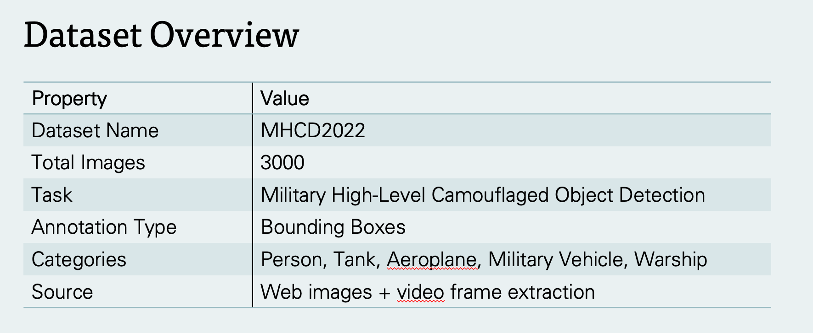

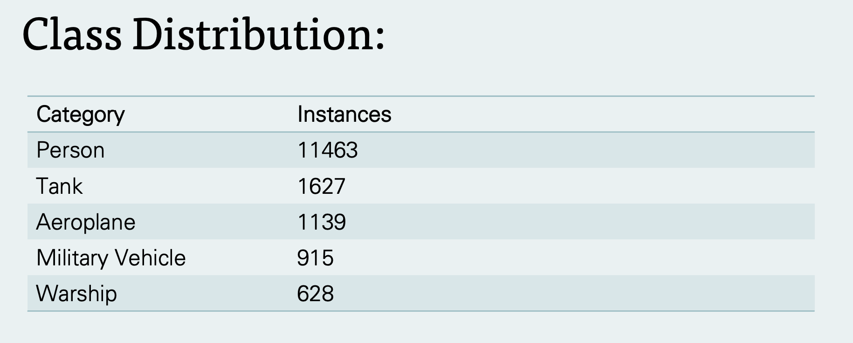

Sample label visualization :

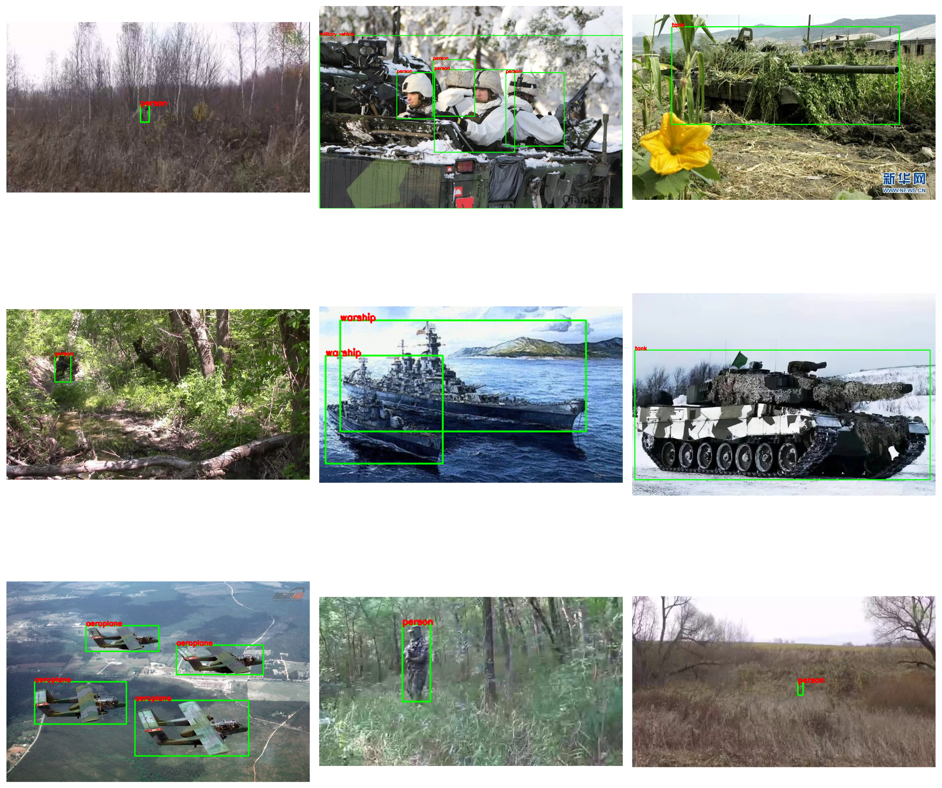
Visualization of the Class Distribution :

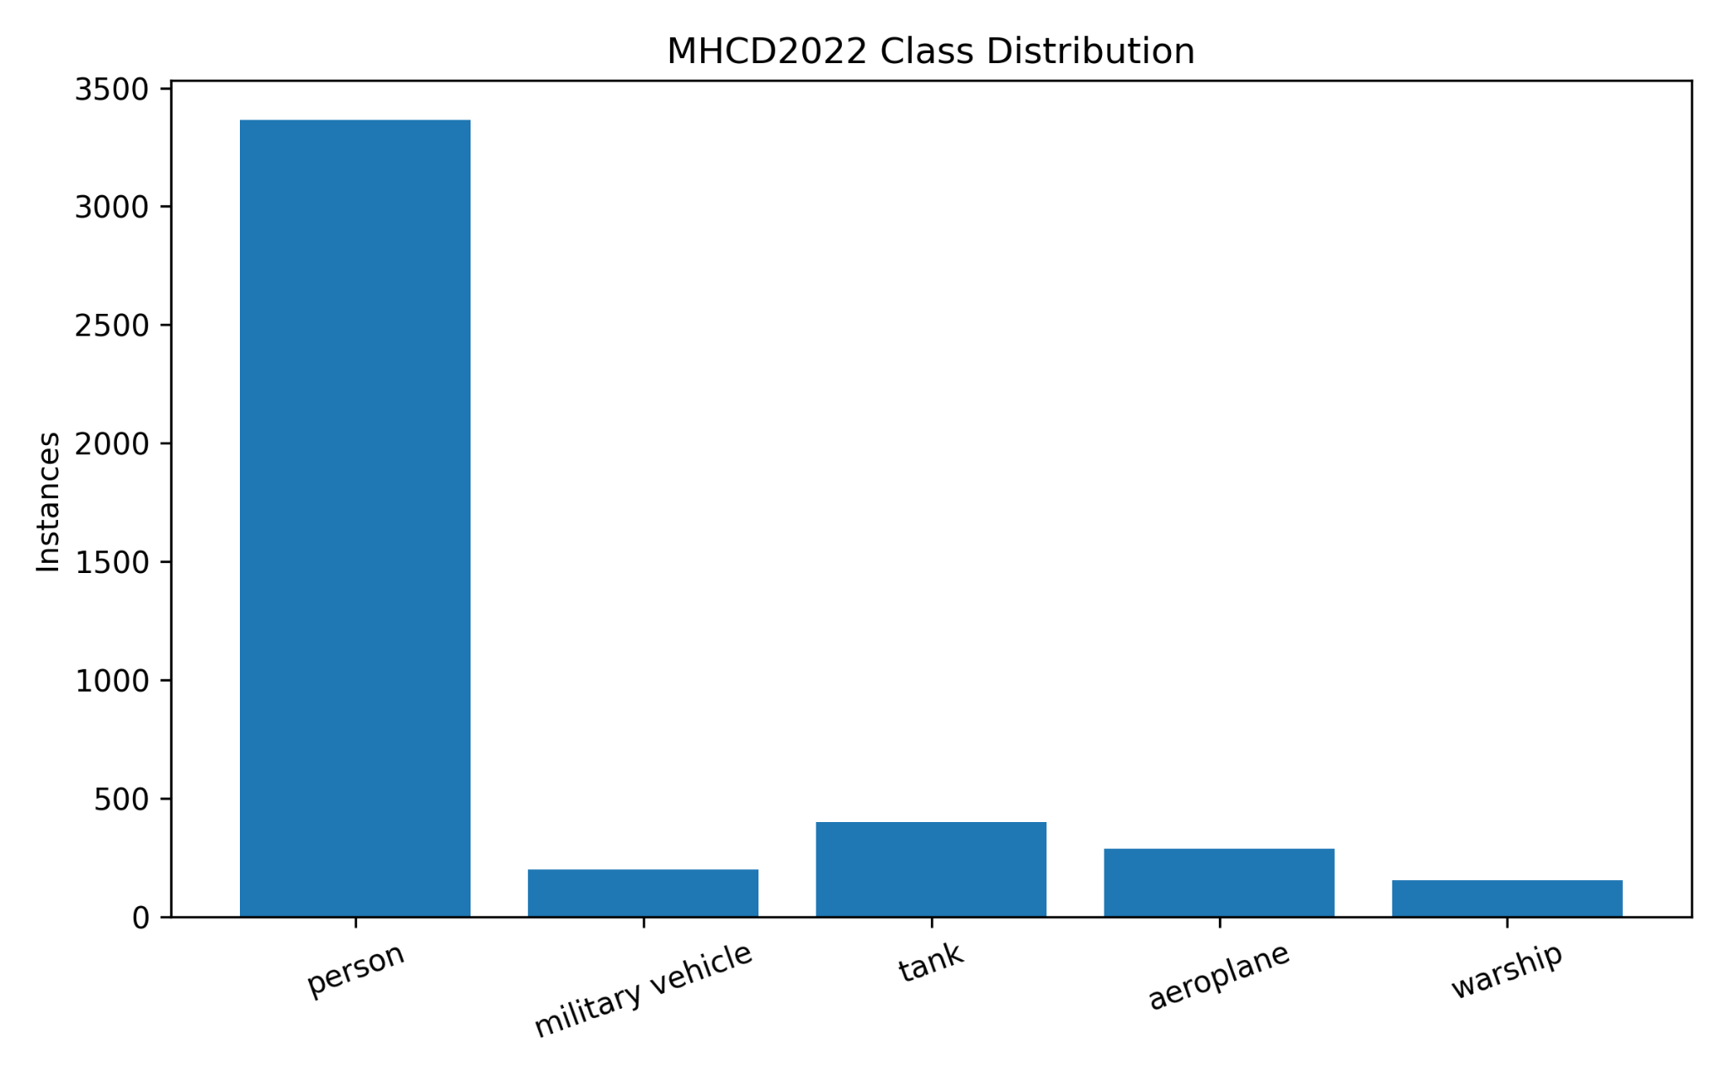

Object Size Comparison to analysis the difficulty level :

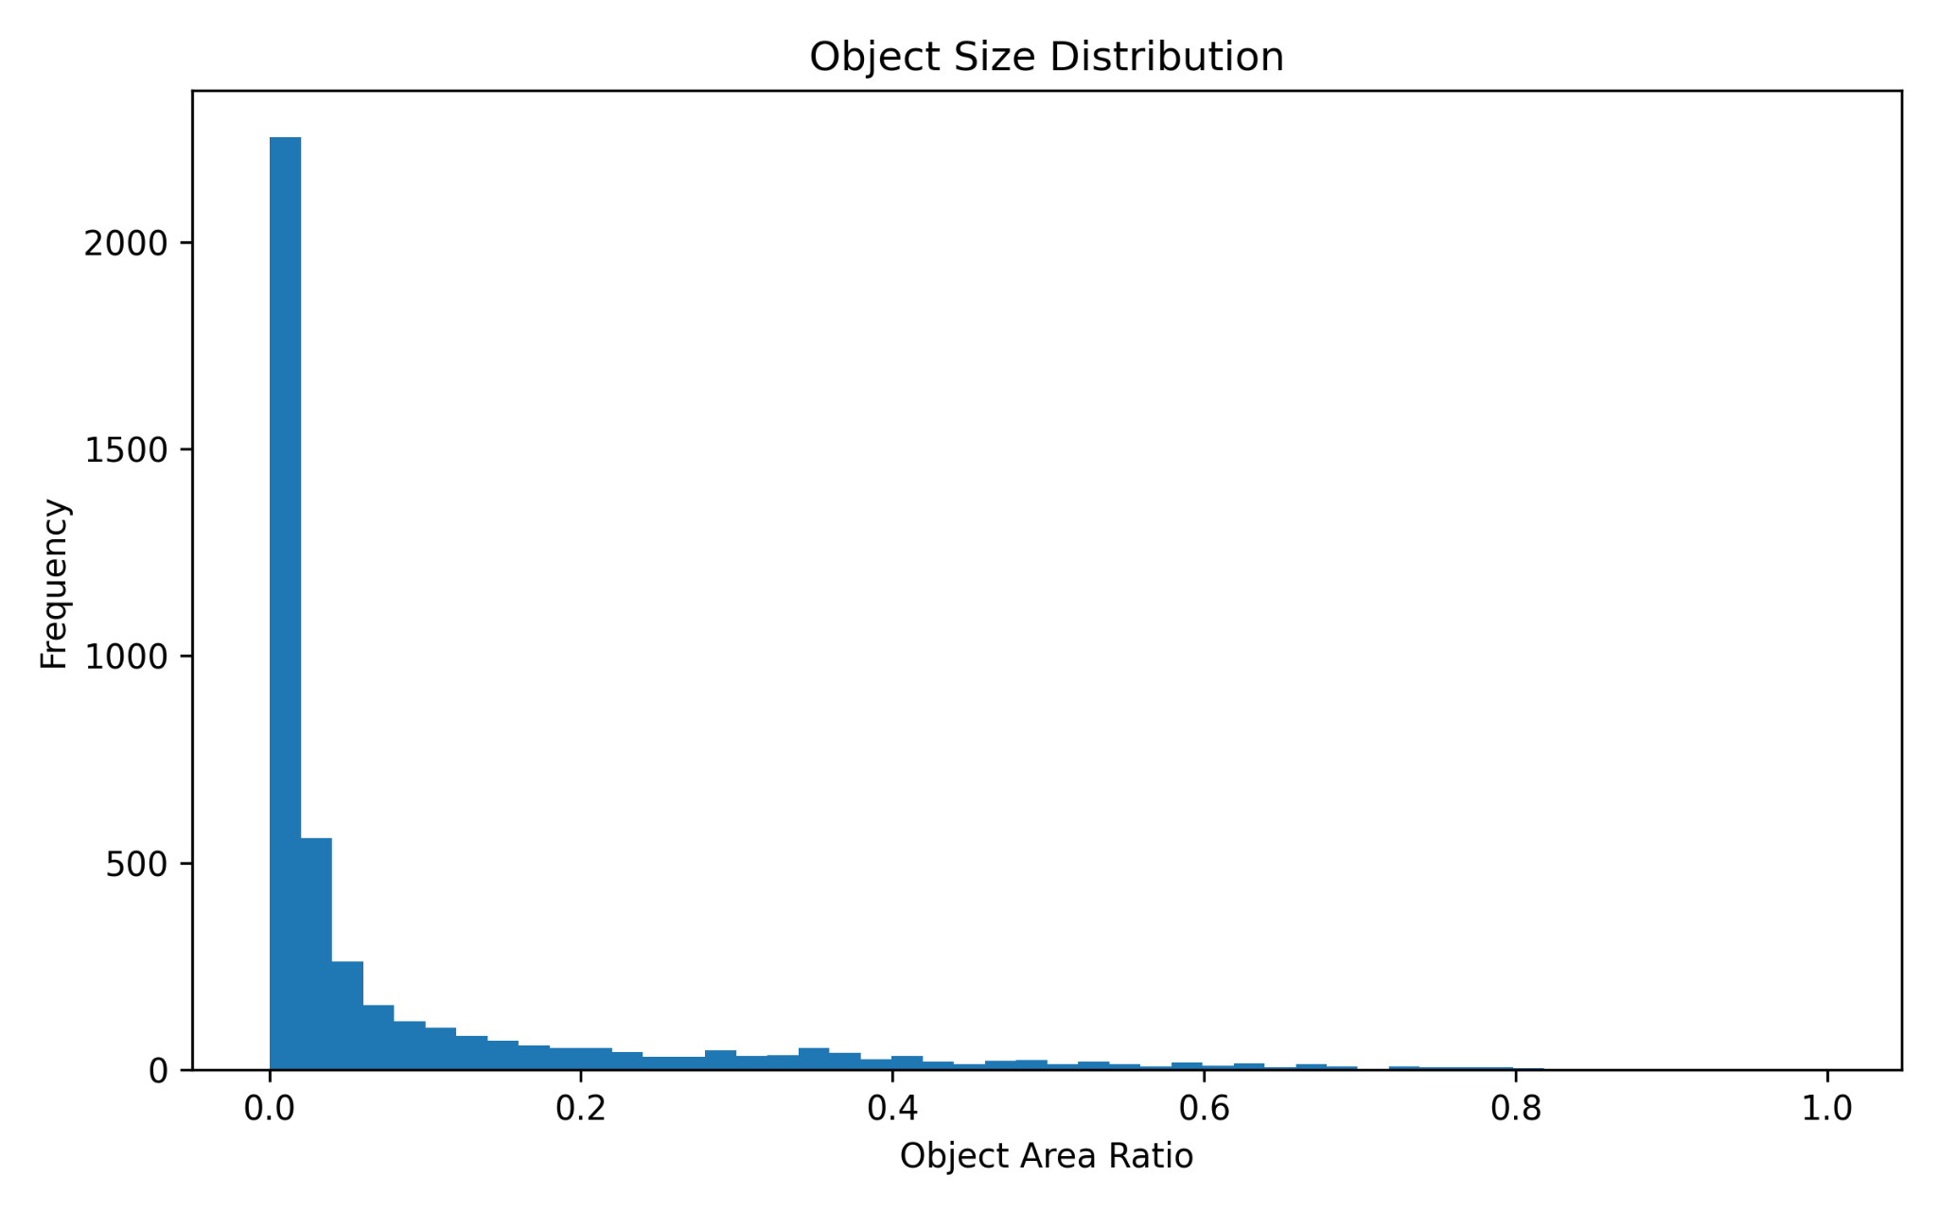
Difficulty Grid :

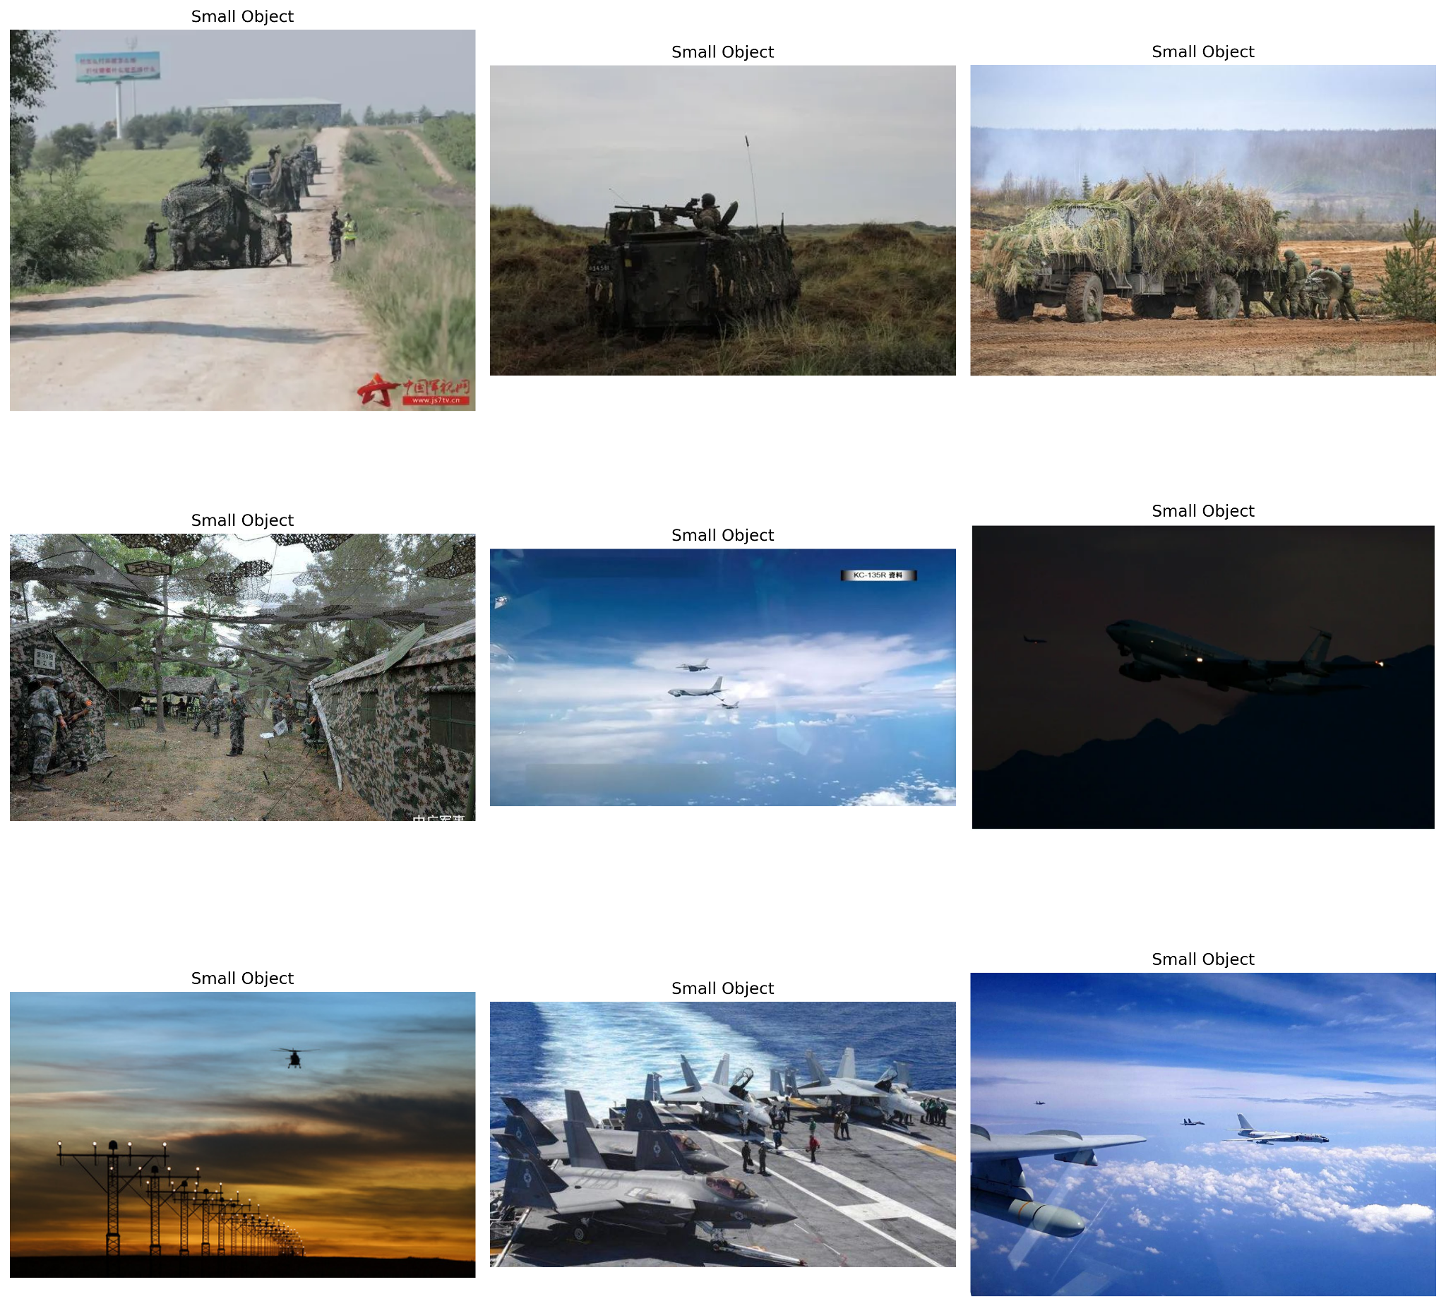

Brief Literature Review ( What has been done ) :
Papers | Review | Methods Used | Advantages | Limitations
Liu & Di (2023) — Extraordinary MHNet: Military High-Level Camouflage Object Detection Network and Dataset(Neurocomputing) | First systematic study of "high-level" military camouflage detection (objects not immediately discernible to the human eye). Introduces the MHCD2022 benchmark (3,000 images, 5 categories: person, aeroplane, military vehicle, warship, tank) and MHNet, a biologically inspired detector that mimics human visual search-and-recovery behaviour. | Four-module architecture on a VGG16/Faster R-CNN backbone: Subject Perception Gathering (SPG) for global "abrupt"/contour-based foreground localization; Part-object Relationships Mining (PRM) using CapsNet/EM-routing for part-whole reasoning; Concept Recovery/Feature Clue Supplement (CR/FCS) via reverse attention to recover occluded cues; Springboard Selection (SS) to correct hard/easy sample domain imbalance via Bayesian distribution alignment. | First dedicated dataset and detector for high-level (hard-to-spot) military camouflage; outperforms strong baselines (AdaMixer, CrossDet++, Decoupled R-CNN, DETR, Cascade R-CNN) on mAP@.75 and mAP@[.5,.95]; thorough ablation isolating each module's contribution; explicit biological-vision rationale for design choices. | Only bounding-box annotations (mask-level labels left for future work); dataset built mainly from web/video crawling rather than authentic battlefield imagery, raising domain-gap concerns; slightly trails AdaMixer on mAP@0.5 and on "aeroplane"/"military vehicle" categories; four-module pipeline adds architectural complexity/compute cost.
Haider & Raza (2026) — Assessment of Camouflage in Heterogeneous Environments through Deep Learning(Engineering Applications of AI) | Benchmarking study introducing ACD1K, a 1,078-image dataset of camouflaged people across forest, desert/rocky, and snow environments with bounding-box + mask annotations. Evaluates eight SOTA COD frameworks on ACD1K and the older CPD dataset under three train/test settings. | No new architecture proposed; instead benchmarks SINet, SINet-V2, ZoomNet, MFFN, ZoomNext, PCNet, HitNet, CamoDiffusion (CNN, transformer, and diffusion-based models) using S-measure, E-measure, F-measure, and MAE; includes Pearson-correlation analysis of object–background colour similarity and cross-dataset transfer-learning tests. | Larger, more diverse human-camouflage dataset than CPD, with finer annotation (mask + bbox) and three camouflage-difficulty levels; rigorous multi-model, multi-setting comparison; demonstrates ACD1K yields better cross-dataset generalization than CPD; useful taxonomy of camouflage pattern types (digital/analogue/hybrid) and material properties. | Purely a benchmarking/dataset contribution — no novel detection architecture; existing models still struggle with heavy occlusion and low object–background contrast; environment classes are imbalanced (e.g., only 86 desert/rocky images vs. 787 forest); none of the benchmarked models are tailored specifically to military-camouflage characteristics.Purely a benchmarking/dataset contribution — no novel detection architecture; existing models still struggle with heavy occlusion and low object–background contrast; environment classes are imbalanced (e.g., only 86 desert/rocky images vs. 787 forest); none of the benchmarked models are tailored specifically to military-camouflage characteristics.
Liu, Wang & Zhou (2023) — Camouflaged People Detection Based on a Semi-Supervised Search Identification Network(Defence Technology) | Extends SINet into Semi-SINet for detecting camouflaged military personnel, addressing both edge/boundary weakness and scarcity of labelled camouflage data. Expands COD10K into COD10K+ with manually added and UAV-captured camouflaged-people images (including unlabeled samples). | Adds an Edge Attention (EA) module exploiting low-level features with a dedicated BCE edge loss; introduces a semi-supervised pseudo-labeling strategy (random sampling + iterative fine-tuning) to exploit unlabeled UAV/web imagery; validated on real UAV reconnaissance footage at multiple flight altitudes. | Directly tackles the labelled-data scarcity problem via semi-supervision; edge attention measurably improves boundary precision; validated on genuine UAV-captured imagery, supporting real reconnaissance applicability; outperforms EGNet, PFANet, and vanilla SINet across all four metrics on both COD10K+ and CPD. | Newly labelled data added is modest (only 600 images); pseudo-labeling can propagate/reinforce errors from an imperfect base model; UAV validation limited to close range (≤10 m altitude), so applicability to higher-altitude aerial reconnaissance is untested; no real-time/onboard inference benchmarking.
Cannaday, Davis & Bajkowski (2023) — Detection of Camouflage-Covered Military Objects Using High-Resolution Multi-Spectral Satellite Imagery (IGARSS) | Investigates whether multi-spectral (MS) WorldView-2/3 satellite bands (beyond RGB) improve detection of camouflage-covered military objects (CCMO). Splits 8 MS bands into 3-band partitions and fuses multiple DNN outputs to boost detection. | DNN classifiers (ResNet-18/101, EfficientNet-B4/B7) trained on RGB, REYC (red-edge/yellow/coastal-blue), and NIRC (NIR1/NIR2/coastal-blue) band partitions and on individual bands; remote sensing indices (NDVI, EVI2, etc.) as pseudo-bands; heuristic and fuzzy-integral data fusion (mean, weighted average, Sugeno/Choquet integrals) across model outputs. | Shows substantial F1 gains (up to +14.4%) over RGB-only baselines by exploiting non-visible spectral bands and fusion; identifies which spectral bands (e.g., red-edge) carry the most discriminative camouflage information; demonstrates fusion of multiple weak learners can rival/exceed single strong models. | Extremely small sample size (37 training / 16 test CCMO instances) — high overfitting risk and limited statistical confidence; larger networks (ResNet-101, EfficientNet-B7) underperform smaller ones, likely due to data scarcity rather than true architectural inferiority; restricted to WorldView sensor bands; framed as patch-level classification rather than fine-grained localization/segmentation.
Haider et al. (2025) — Identification of Camouflage Military Individuals with Deep Learning Approaches DFAN and SINetV2 (Scientific Reports) | Introduces MSC1K, a 1,000-image dataset of camouflaged soldiers/snipers (desert, snow, rocky, forest) with bounding-box and mask annotations across three camouflage-difficulty levels, and proposes DFAN (Dynamic Feature Aggregation Network), benchmarked against SINet, SINet-V2, and ZoomNet on MSC1K, CPD, and a combined setting. | DFAN: multi-view generation (distance-zoom + diagonal/vertical mirror views), ResNet-50 Layered Feature Encoder, two-stage Co-Attention of Multi-view (CAMV) module, Channel Fusion Unit (CFU), and Overall Progressive Iteration (OPI) for hierarchical refinement; trained with combined BCE + uncertainty-aware loss; compared against SINet/SINet-V2/ZoomNet using S-, E-, F-measure and MAE. | DFAN achieves the lowest MAE across all three dataset settings and the best precision–recall (F-measure) balance, especially on the combined MSC1K+CPD setting; new richly annotated, multi-environment, difficulty-stratified dataset; detailed cross-dataset comparison highlighting how dataset diversity affects model generalization (e.g., SINet underperforms on low-contrast CPD). | Multi-view generation in DFAN increases inference cost (multiple view passes per image); dataset remains modest in size (1,000 images) relative to general COD datasets like COD10K; SINet's weak performance on CPD highlights that older single-view architectures generalize poorly to subtle/low-contrast camouflage; no evaluation of real-time or embedded/UAV deployment.

Model Results :

IoU results :
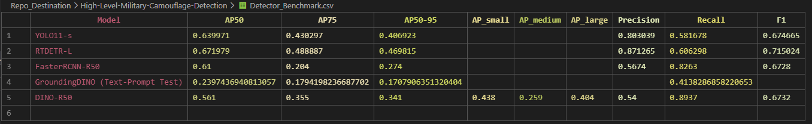

Classwise Benchmark :
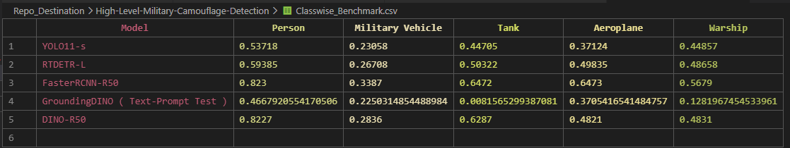

Robustness Benchmark :
Robustness_Benchmark.xlsx

Relative AP Drop :
Relative_AP_Drop.xlsx

Average Robustness:
Table1_Average_Robustness.xlsx

Worst Corruption :
Table2_Worst_Corruptions.xlsx

YOLO11s Prediction Samples :

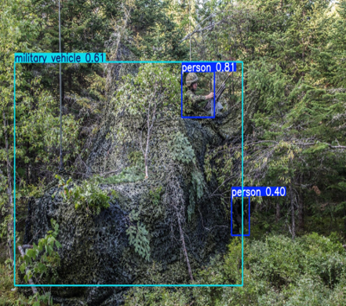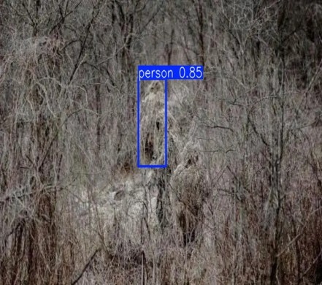
RTDETR-L Prediction Samples :
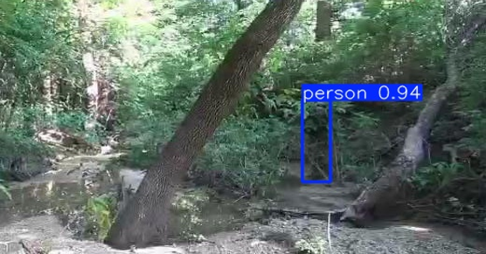
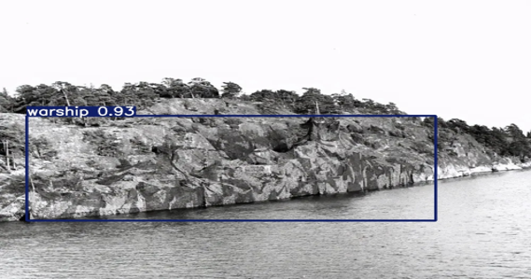
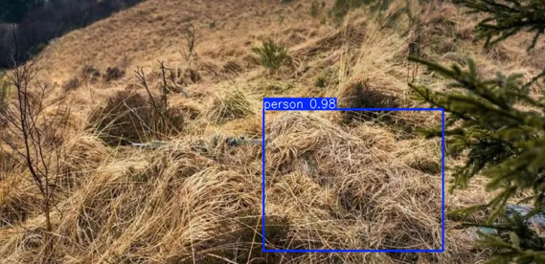
FasterRCNN-R50 Prediction Examples :
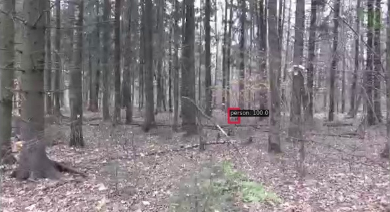
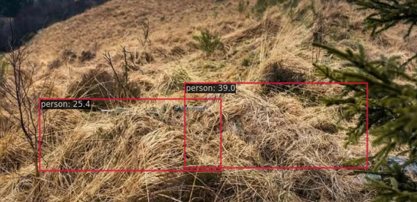
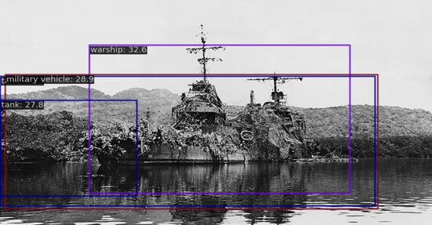
So, The Best Performing Model is RTDETR-L
Failure Analysis : (This is out of Evaluated Failures of RTDETR-L)
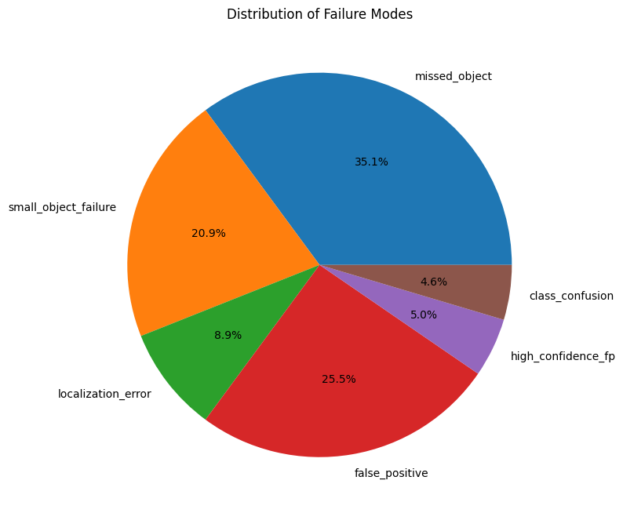
These are all the failures :
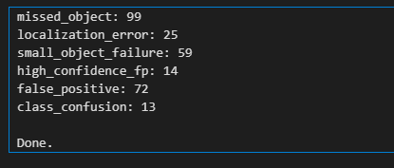

Missed-Object Example :
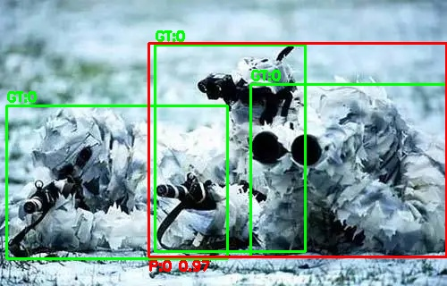
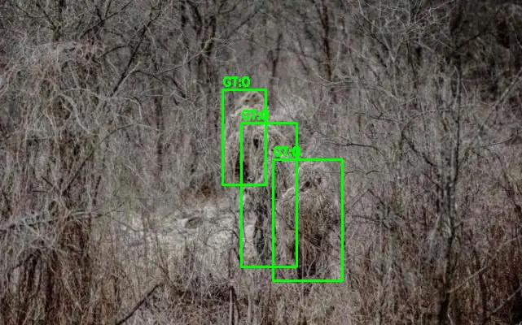
Small-Object Failures :
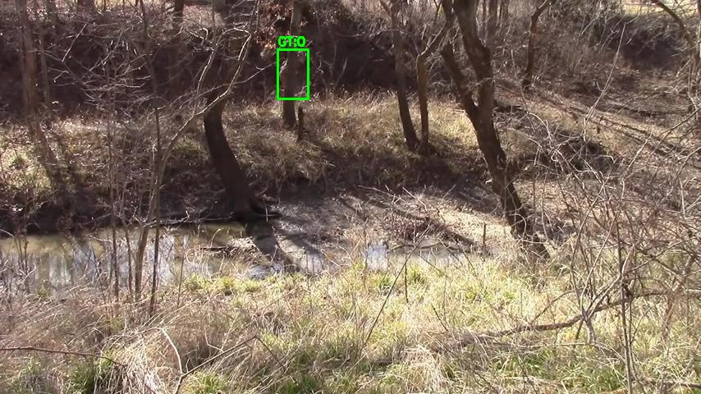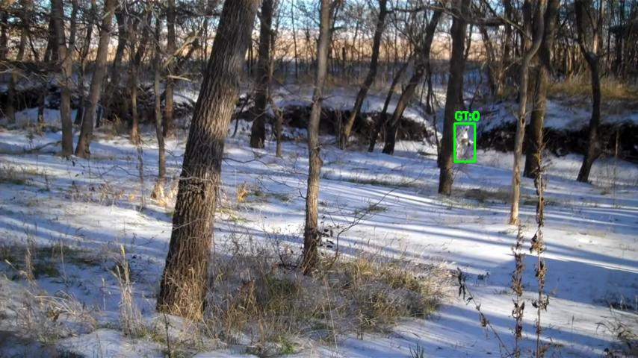

Localization Errors :
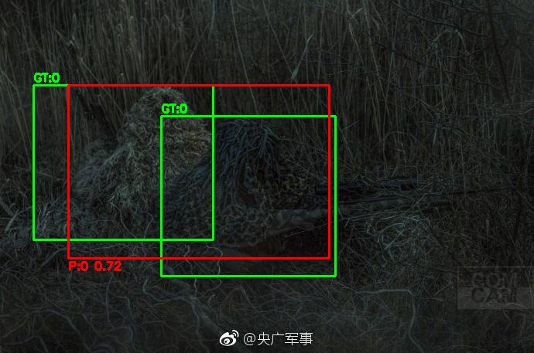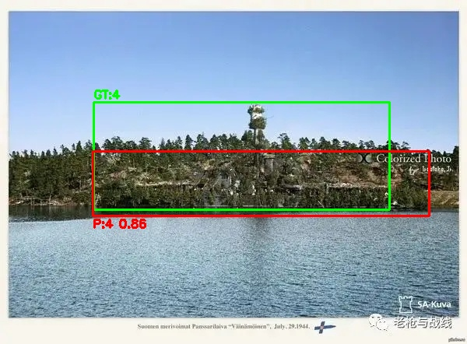\
False-Positives :
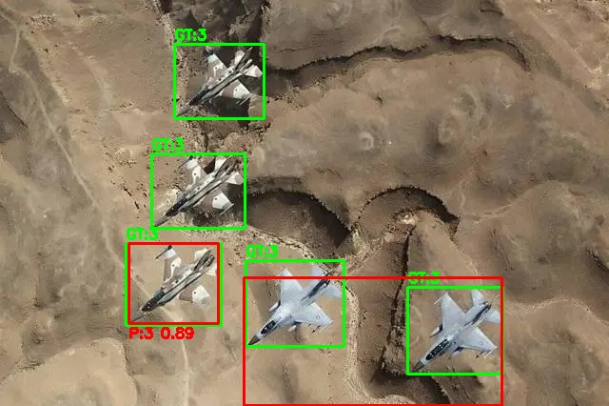
High Confidence False-Positives :
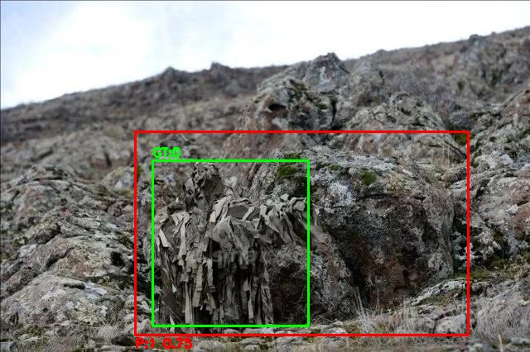

Works Done So far :
All the Tasks are done up to Task 13 which is Failure Analysis for MHCD2022 dataset.

Next Goal :

Standard models fail clearly on heavy camouflage cases, small objects often go undetected with the Standard Models and also performance drops strongly under low light, fog or blur. So, the next goal should be improving the reliability of standard models and generalizing the results using other datasets.

Mixup strategies for resolving the class imbalance issue in visual object detection

MHNet, Class Imbalance issue resolve

